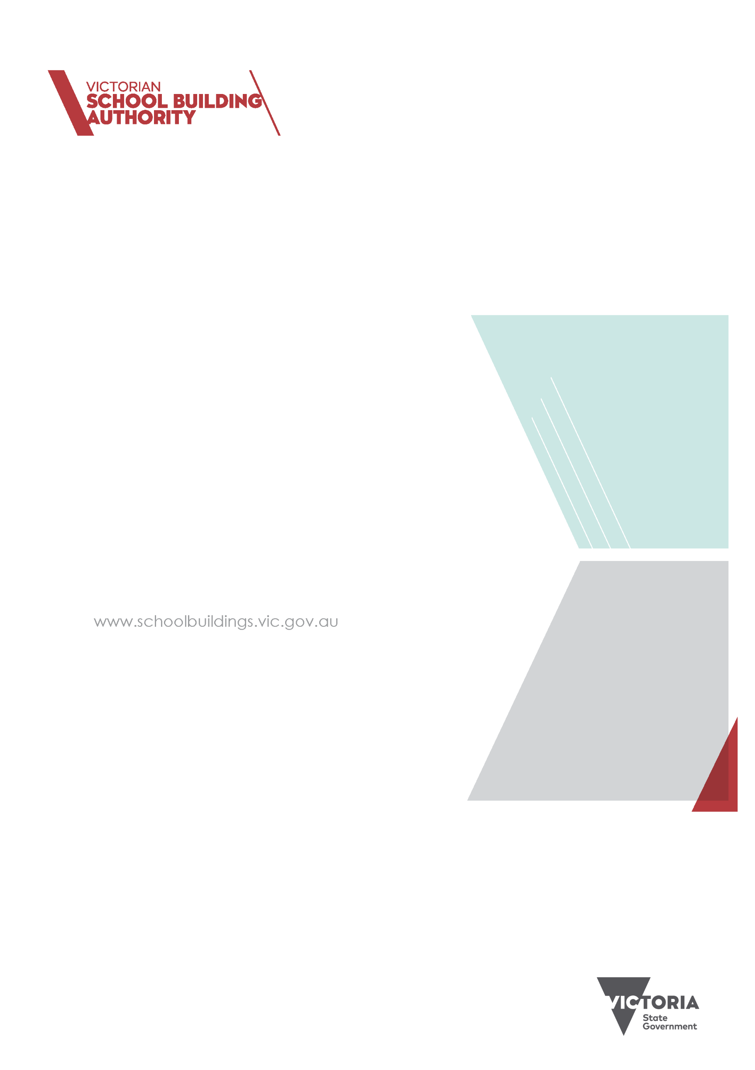

rEFURBISHMENT AND

MINOR WORKS
Round 2

2021 Program
Guidelines

Published by the
Victorian School Building Authority
Department of Education and Training
Melbourne
June 2020

© June 2020 State of Victoria (Department of Education and Training)

The copyright in this document is owned by the State of Victoria (Department of Education and Training), or in the case of some materials, by third parties (third party materials). No part may be reproduced by any process except in accordance with the provisions of the Copyright Act 1968, the National Education Access Licence for Early childhoods (NEALS) (see below) or with permission.

An educational institution situated in Australia which is not conducted for profit, or a body responsible for administering such an institution may copy and communicate the materials, other than third party materials, for the educational purposes of the institution.

Authorised by the Department of Education and Training
2 Treasury Place, East Melbourne, Victoria, 3002.
This document is also available on the internet at: schoolbuildings.vic.gov.au/Pages/EarlyChildhoodMinorWorks

Table of Contents
Refurbishment and minor works program objectives 4
What Type of Grant can I apply for? 4
Minor Works and Refurbishment 4
Major Works and refurbishment 4
Who can apply? 6
Auspice arrangements 6
Assessment 6
Past performance 7
Funding conditions 7
Additional conditions for projects involving government school sites are outlined in Section 12 of these guidelines. Section 3 of the VSBA’s Building Quality Standards Handbook also includes information that, while primarily designed for schools, may assist with design of your project 7
NON-GOVERNMENT organisations 7
Relationship with other funds 8
Project management requirements 8
Project reporting requirements 8
Project delivery 8
Project extensions 9
Acquittal requirements 9
How to apply 9
Projects on DET land 9
Application Checklist 10
Further information 11
Information privacy 11

Refurbishment and minor works program objectives
The Refurbishment and Minor Works Program will help improve the learning environments, condition or character of Victorian kindergartens. The program also aims to stimulate economic activity by supporting local jobs across Victoria.
Funding is intended to:
- upgrade the condition of kindergartens
- improve kindergarten amenities
- stimulate the local economy by funding projects that support local jobs and communities.

What Type of Grant can I apply for?
As with round 1, two types of grants can be applied for under the Refurbishment and Minor Works round 2 program:
- Minor Works and Refurbishment
- Major Works and Refurbishment

If you applied for a project under Round 1 of this Program, you are still eligible to apply for an additional project in Round 2, however a second application may be deprioritised over other applications.

Minor Works and Refurbishment
Purpose of grant
The Minor Works and Refurbishment stream funds small-scale works to existing early childhood infrastructure (including playgrounds) across the state.
Project requirements
Your project must be for a facility located in Victoria that is, or will be, licensed to provide a funded Three and Four-Year-Old Kindergarten program, and must offer or intend to offer both programs. This can be sessional or integrated with long day care. If you are unable to deliver both programs, please contact the VSBA Early Childhood Grants team to discuss your options.
Funding available
Eligible organisations can apply for up to $50,000 per grant (GST exclusive).
Co -contributions are allowed but not required for applications under the Minor Works and Refurbishment stream.
Project completion
Projects funded under the Minor Works and Refurbishment stream are expected to be completed and acquitted within 8 months following the execution of a Common Funding Agreement (CFA) between the grant recipient and the Victoria School Building Authority (VSBA).
Funding agreements must be signed and submitted to the VSBA by an authorised officer of the recipient organisation no later than four weeks after receipt.
In cases where a project is delayed for an unreasonable length of time, or where substantive changes to scope are made after funding has been approved, the VSBA reserves the right to cancel the grant and, if applicable, recoup any funds that have already been provided.

Major Works and refurbishment
The Major Works and Refurbishment stream funds larger scale works to existing early childhood infrastructure (including playgrounds) across the state.

Project requirements
Your project must be for a facility located in Victoria that is, or will be, licensed to provide a funded Three and Four-Year-Old Kindergarten program, and must offer or intend to offer both programs. This can be sessional or integrated with long day care. If you are unable to deliver both programs, please contact the VSBA Early Childhood Grants team to discuss your options.
In cases where a project is delayed for an unreasonable length of time, or where substantive changes to scope are made after funding has been approved, the VSBA reserves the right to cancel the grant and, if applicable, recoup any funds that have already been provided.
Funding available
Eligible organisations can apply for grants valued between $50,000 and $500,000 per grant (GST exclusive).

Co -contributions are allowed but not required for applications under the Major Works and Refurbishment stream.
Project completion
Projects funded under the Major Works and Refurbishment stream are expected to be completed and acquitted within 12 months following the execution of a CFA between the grant recipient and the VSBA. Funding agreements must be signed and submitted to the VSBA by an authorised officer of the recipient organisation no later than four weeks after receipt.
In cases where a project is delayed for an unreasonable length of time, or where substantive changes to scope are made after funding has been approved, the VSBA reserves the right to cancel the grant and, if applicable, recoup any funds that have already been provided.

What can (and cannot) be funded?
What can be funded | What cannot be funded
- project management costs  - planning and design costs  - site preparation, including clearing or demolition (if the project will be on DET owned land, please contact the VSBA before applying to confirm how these costs can be funded)  - construction and commissioning  - landscaping and car parking  - fixed fittings and fixed equipment  - removal of contaminants on project sites (e.g. asbestos/arsenic), pending it is within scope of the state’s financial contribution and included at application stage  - staff-room upgrades  - double glazing and insulation  - kitchen upgrades  - replacement/installation of water tanks  - toilet upgrades  - fixing roofing leaks  - fencing  - playgrounds  - accessible ramps | - site acquisition and lease costs  - purchase of cars, buses and other vehicles  - ongoing administration or operational costs  - staff salaries and training  - additional funding due to project cost overruns  - purchase of relocatable buildings (including ‘pods’) which would extend or increase the number of early childhood buildings  - information technology costs  - loose furniture (non-fixed) and specialist disability equipment e.g. specialist chairs, toilet frames, blinds and curtains  - Fire services equipment including fire extinguishers

Round 2 of the Refurbishment and Minor Works Program will not fund projects that:
- are not at facilities which offer (or are intending to offer) both funded Three and Four-Year-Old Kindergarten programs
- are located outside Victoria
- do not align with the program principles
- do not meet the requirements outlined in these guidelines
- do not address the assessment criteria
- have already started or been completed (i.e. retrospective funding).
If you submitted an application in round 1 of the program, you are eligible to submit another application for a separate project in round 2.

Who can apply?
Your organisation can apply if it is one of the following:
- a Victorian Local Government Area (Council)
- a not-for-profit community organisation that is a legal entity (for example an incorporated association, incorporated cooperative or Indigenous corporation)
- a Victorian government school
- a Victorian non-government school registered with the Victorian Registration and Qualifications Authority or Catholic Education Commission of Victoria.
For-profit organisations cannot apply for any grant streams under the Refurbishment and Minor Works Program.
Should you need any assistance clarifying your not-for-profit status, please contact the VSBA Early Childhood Grants team.

Auspice arrangements
Not-for-profit community organisations in the process of becoming incorporated, or those without capacity to manage the funding, may arrange for an eligible organisation to apply on their behalf. This is known as an ‘auspice’ arrangement.
We directly fund the auspice organisation, and they agree to take the full legal and financial responsibility for the project. You can find more information about auspicing arrangements at www.nfplaw.org.au/auspicing.
If you would like to negotiate an auspice arrangement, you are responsible for identifying an auspice organisation and working with them to prepare the application. The VSBA will not make auspicing arrangements on your behalf.
Auspice arrangements cannot be used by for-profit organisations to apply for any grants streams.

Assessment
Once the closing date for applications has passed, the VSBA will:
- check to confirm that applications meet the eligibility requirements
- assess all eligible applications against the assessment criteria.
The VSBA may also undertake further project cost assessment in instances where project costs are complex, or clarification is required.
Following this process, the VSBA will provide its recommendations to the Minister for Early Childhood for final approval. The Minister reserves the right to provide strategic investment to projects.
In addition to normal value for money principles, our funding recommendations will be based on the extent to which you can demonstrate that your project addresses the following assessment criteria.

Refurbishment and Minor Works
All applicants should address the assessment criteria:
Assessment Criteria
- Proposed project improves the physical condition or character of existing facilities that are licensed for three and four-year-old kindergarten (50%)
- Proposed project improves access to high-quality three and four-year-old services for the local community (30%)
- Project is ready to commence (20%)

Past performance
We will review your past performance and assess whether this is likely to have an impact on successful delivery of your project. This will include considering whether you have:
- taken appropriate steps to deliver previous projects funded through Building Blocks (previously the Children’s Facilities Capital and Inclusive Kindergartens Facilities programs) within appropriate timeframes
- overdue projects funded by the VSBA and whether extensions have been requested and approved
- completed projects funded by the VSBA and whether you have submitted all documentation required to acquit the grant funding, including regular monthly reporting and acquittal within the contracted time frame.

Funding conditions
Early childhood facilities funded through the Refurbishment and Minor Works Program must:

- be operated by an organisation that is licensed to provide funded kindergarten services in Victoria
- offer or intend to offer a funded three and four-year-old kindergarten program for children
- operate as a funded kindergarten service for four years from project completion.

To remain eligible for funding, you must not enter into a contract or commence any works proposed in your application before we inform you of the application outcome.

Organisations that receive a grant must:
- agree to the requirements outlined in these guidelines (failure to do so may result in funding being withheld)
- enter into a formal CFA with the VSBA
- complete the project within the timeframes specified in the CFA
- where applicable, follow the Acknowledgement and Publicity Guidelines, including liaising with the VSBA and holding events on request, such as sod turns and openings, and erecting signage for projects
- submit an acquittal form and the required supporting evidence for approval by the VSBA upon completion of the project
- agree that no additional VSBA funding will be allocated to the proposed project and if additional costs arise, they must be met by the applicant.

We encourage you to review the Acknowledgement and Publicity Guidelines, and standard terms and conditions, before submitting your application. These documents will clarify your obligations for receiving Refurbishment and Minor Works funding. They are available on the VSBA website.
We will only vary the conditions of the standard CFA in exceptional circumstances. Using the standard CFA should minimise the need for legal advice; however, applicants must pay any legal costs they incur in relation to the funding agreement (these costs may be budgeted into the total project cost and funded through the grant).
All projects are expected to adhere to relevant building guidelines and regulations.

Additional conditions for projects involving government school sites are outlined in Section 12 of these guidelines. Section 3 of the VSBA’s Building Quality Standards Handbook also includes information that, while primarily designed for schools, may assist with design of your project

NON-GOVERNMENT organisations
The Betrayal of Trust Report found that survivors of institutional child abuse were sometimes unable to identify an appropriate legal entity to sue.
The Royal Commission into Institutional Responses to Child Sexual Abuse also recommended that governments consider requiring organisations they fund to be insured against child abuse.
From 1 July 2019, non-government organisations funded by the Victorian Government to deliver services to children will be required, as a condition of funding to be:
- incorporated separate legal entities that can be sued in their own right in child abuse proceedings
- appropriately insured against child abuse.
The new requirements will improve the ability of child abuse survivors to bring a legal claim for compensation and ensure that successful claims can be paid.

Relationship with other funds
There are a number of other grant programs that provide funding for upgrades to early childhood facilities and services. The VSBA needs to be advised of other funding applications for your project. We reserve the right to consider grant applications made for other programs, offered by the VSBA or other government departments. We also reserve the right to submit applications to other department agency-led grant programs for consideration for funding under those programs where appropriate.

Project management requirements
A qualified and experienced project manager must be identified at the time of application and appointed within four weeks of the funding announcement.
The name and contact details (email, telephone number, including mobile) of the proposed project manager must be included in the application. The project manager must be appointed before the CFA can be executed.
Failure to follow these requirements regarding a project manager could ultimately result in the VSBA recommending to the Minister for Early Childhood to withdraw the funding commitment.

Project reporting requirements
As a condition of grant funding for the Refurbishment and Minor Works Program, successful applicants must comply with project monitoring and reporting requirements, including:
- monthly status reports through an online reporting system to provide an update on progress, updating proposed, forecast and actual dates for project milestones, flagging risks and issues, and providing the required evidence when payment milestones have been met
- advising the VSBA in advance of key milestones including architect appointment, design completion, sod turn and construction completion and providing opportunities for public communication of these milestones
- advising the VSBA of scope changes (relating to time, cost and project scope) by completing and submitting a variation form via the online reporting system
- site inspections, meetings and teleconferences with VSBA staff or representatives if required
- production of building contracts, receipts and/or invoices when requested.

Project delivery
Successful Refurbishment and Minor Works grant applications will be funded subject to the execution of a CFA with the VSBA. Successful applicants will be required to comply with project monitoring and reporting requirements described in these guidelines. These include:

- signing a CFA to be executed by the VSBA
- completing online, monthly progress reports with supporting evidence as required by the VSBA
- allowing site inspections and teleconferences by staff or representatives of the VSBA if required
- producing building contracts, receipts and/or invoices if required by the VSBA
- completing acquittal forms for milestone instalments including supporting evidence
- submitting final acquittal documentation within agreed timeframes.

Payments will be provided in milestone instalments at the discretion of the VSBA. Milestone instalments will be paid to successful applicants via an electronic funds transfer to a nominated account.

All projects must be delivered, and final acquittals made within either 8 or 12 months of execution of the CFA (depending on what stream you are applying to).

In cases where a project is delayed for an unreasonable length of time, or where substantive changes to scope are made after funding has been approved, the VSBA reserves the right to cancel the grant and, if applicable, recoup any funds that have already been provided. On completion of the project, all grant recipients are required to complete and return the appropriate Certificate of Expenditure Acquittal form, which will be provided as part of the online reporting process.

Project extensions
Recipients must contact the VSBA immediately if they require a project extension. Applicants will be required to complete a variation form providing detailed evidence that explains the reason for the delay and demonstrates that the project will be completed within the additional time requested.
Project extensions are not guaranteed to be approved. Excessive delays may ultimately result in the VSBA recommending to the Minister for Early Childhood to withdraw the funding commitment.

Acquittal requirements
All successful applicants are required to complete the following requirements and upload the following information into the VSBA reporting system to complete their acquittal:
- certificate of final completion
- certificate of occupancy (if required)
- certified project expenditure list on letterhead and signed by an authorised representative
- the VSBA’s Certificate of Expenditure Acquittal, completed, signed and dated by two authorised representatives
- before and after photos of completed project

Please note, non-acquittal, incomplete acquittal or lack of invoices and evidence of expenditure may jeopardise future funding allocations to an organisation.

How to apply
Applications for both categories of the Refurbishment and Minor Works program open on 26 March 2021.
Applications close at 11:59 p.m. on 21 May 2021.
Application forms can be accessed online at https://vsba.smartygrants.com.au/. Applicants must be registered to use the Smarty Grants application system. Registration is a free and straightforward process.
For assistance with the online application system, please contact the Smarty Grants Support Desk by phone on (03) 9320 6888 between 9am and 5pm Monday to Friday or email service@smartygrants.com.au. You can also find a help guide and Frequently Asked Questions at http://applicanthelp.smartygrants.com.au/
All sections must be completed, and the application form submitted to be considered for funding. Changes can be made to an application any time until it is submitted.
The VSBA will not consider late applications.

Projects on DET land
If you propose a project on Department of Education and Training (DET) land, you must contact the VSBA’s Early Childhood Grants team as early as possible during the development of your proposal to discuss the approach to land and project delivery. Phone (03) 7022 2564 or email building.blocks@education.vic.gov.au.
- Applications for projects on DET land must include a completed Land Use Proposal Form and must enter into a lease agreement with the VSBA in addition to their CFA. Further information on these requirements can be found in the Frequently Asked Questions, available on the VSBA website.

Application Checklist
The grants offered under the Refurbishment and Minor Works Program are highly competitive and organisations need to ensure that their application includes clear and convincing supporting documentation to increase the chances of being successful.
Depending on the grant you are applying for, you may need to provide:
- considered responses to the selection criteria, that demonstrate how the project will meet these
- two appropriate quotes/ cost estimates from a building professional registered for a trade that is consistent with the scope of the proposed works, for projects valued less than $200,000
- a Quantity Surveyor report from a qualified Quantity Surveyor for works valued at $200,000 or more
- where soil works will be conducted, a Tier 1 preliminary soil assessment report from a qualified soil hygienist
- where internal building works will be conducted, an asbestos audit report will be required
- professional schematic design drawings
- a site plan to illustrate what parts of the land or building will be changed by your project
- a project plan to support the dates nominated in the application for stages of the project.

If you are a not-for-profit or a non-government school, you are also required to provide:
- evidence of not-for-profit status (such as a copy of your Australian Business Number, registration as a not-for-profit, certificate of registration as charity, or a certificate of registration as an incorporated association)
- a signed certified accountant’s confirmation of the applicant’s last two years financial statements as evidence of financial viability
- if an auspice arrangement is proposed, written confirmation from the auspicing party.

Required evidence
The type of evidence required depends on who owns the land. You must provide evidence of:
- building ownership
- authorisation to build on the site
- intention to operate an early childhood facility for at least four years after completing the project
- land ownership:
  - If you own the land for your nominated project site, you can provide a copy of the land title, LANDATA documents or council rates notice showing your organisation’s name and the service address.
  - If the local government or a third party own the land, you must provide a copy of the title with project address and owner’s name as well as the current lease with an end date at least four years after completing the project:
    - If the current lease will end earlier than four years from the date that the CFA is signed, the applicant will need to provide a letter from the landowner stating they intend to allow the facility to operate as a kindergarten for at least four years after completing the project.
    - We also require signed, written approval to undertake the works (on letterhead of the organisation) from the landowner.
  - Where the landowner is not the building owner, the applicant needs to provide evidence of:
    - title of building ownership
    - permission to undertake works
    - authorisation for the applicant to use the building to operate a kindergarten for 4 years after completing the project.
  - If the land is owned by DET, you should complete a Land Use Proposal Form. The form can be found on the VSBA website.

Further information
We encourage applicants to read the Frequently Asked Questions available on the VSBA website.
For further information regarding eligibility, program requirements and assessment criteria, please contact the VSBA Early Childhood Grants team by phone on (03) 7022 2564 or email building.blocks@education.vic.gov.au.
Prospective applicants are also encouraged to discuss their project with the Early Childhood Quality Participation and Access Manager in their area. Full DET regional office contact details are available on their website.
For further information regarding three-year-old kindergarten reform, please visit https://www.vic.gov.au/kinder.

Information privacy
The information you provide will be dealt with in accordance with the Public Records Act 1973 and the Privacy and Data Protection Act 2014.

